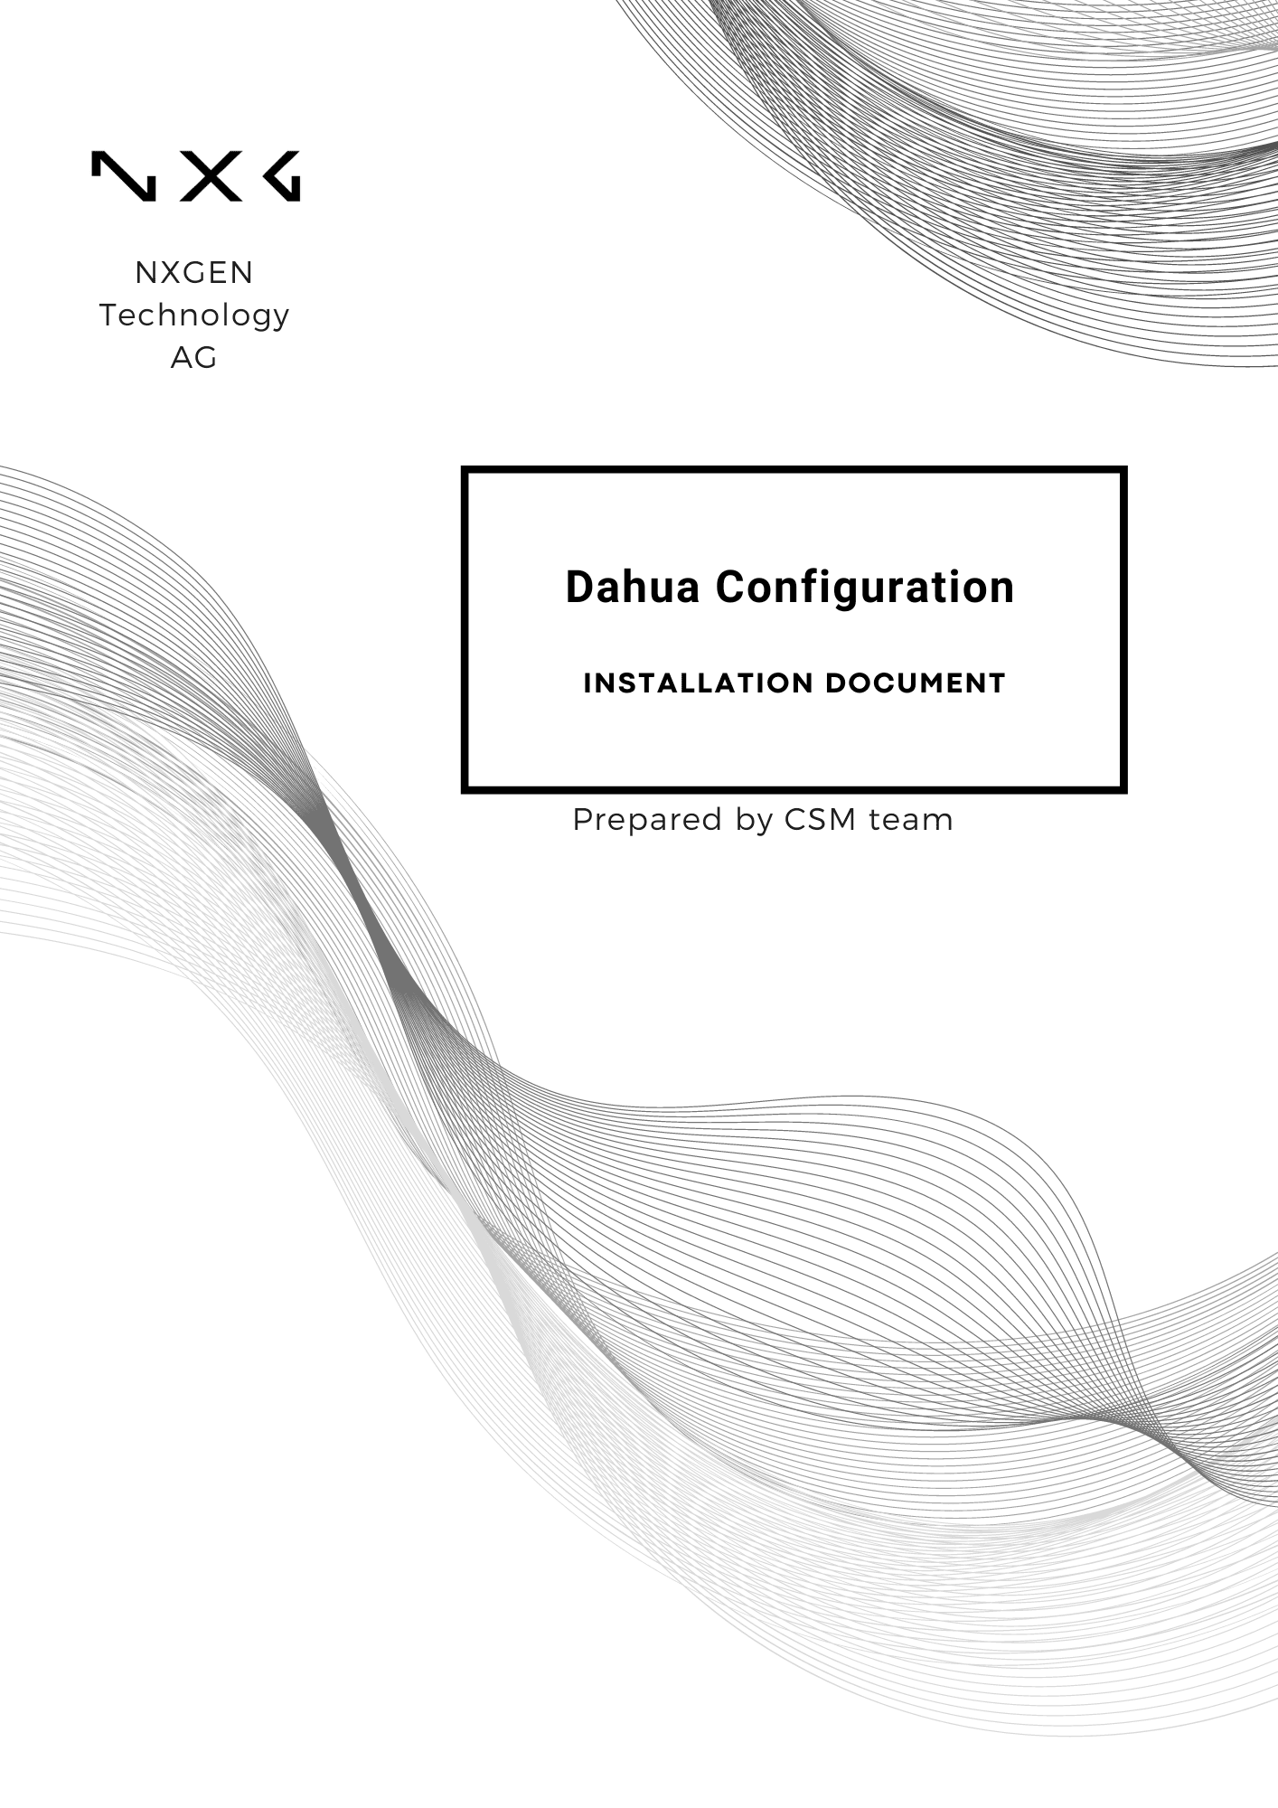

Disclaimer:
This document is provided under NXGEN Technology Ltd's (NXGEN) General Terms & Conditions.
https://www.nxgen.io/en/gtc/

Intellectual Property and Copyright:
All content, including but not limited to text, graphics, logos, images, audio clips, and software, available on NXGEN's platforms and services is the intellectual property of NXGEN or its licensors and is protected by copyright laws. Unauthorized reproduction, distribution, or modification of any content without prior written consent from NXGEN is strictly prohibited. Users are granted limited, non-exclusive, and revocable permission to access and use the content for personal or internal business purposes only. Any misuse or infringement of NXGEN's intellectual property rights will be subject to legal action.

https://www.nxgen.io/

Table of Contents
Disclaimer: 2
Introduction: 3
Prerequisites: 4
Steps to configure Dahua device: 4
Chapter 1: Setting up a user. 4
Chapter 2: Alarm configuration (Optional). 7
Chapter 3: AI configuration (IVS). 11
Dahua Device configuration Guide with GCX-ONE 18

Introduction:
This report provides a comprehensive guide on configuring Dahua devices to work seamlessly with the GCX-ONE platform. By following these steps, users can ensure optimal performance and security for their surveillance systems. The configuration process involves setting up GNS parameters and fine-tuning settings within the Dahua device for enhanced functionality and user experience.
This guide is intended for system administrators and IT professionals who are responsible for the installation and maintenance of Dahua devices in their network infrastructure.

Prerequisites:
- Whitelist the IP 52.59.60.20 (Dahua Receiver). If you don’t use NXGEN OpenVPN services.
- Local Mode is installed (For P2P streaming, Audio, Encrypted stream) in operator workstations.
- Configure the new IP address given by NXGEN in case of using NXGEN OpenVPN services.

Steps to configure Dahua device:

Chapter 1: Setting up a user.
- Log in to your Dahua portal by providing the credentials needed.
- From the home page, navigate to the bottom right corner and select "Accounts."
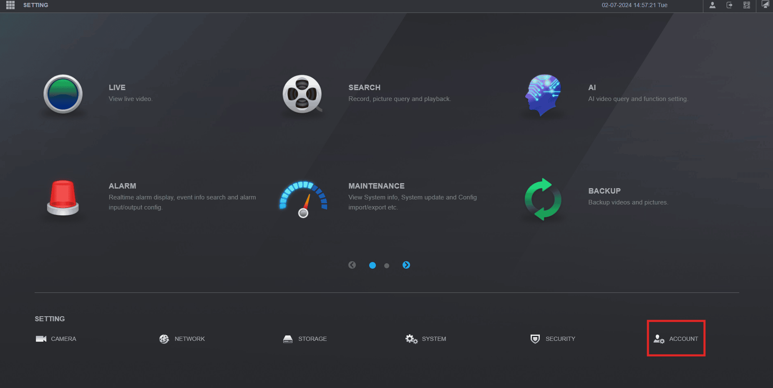
- Click on "Add".
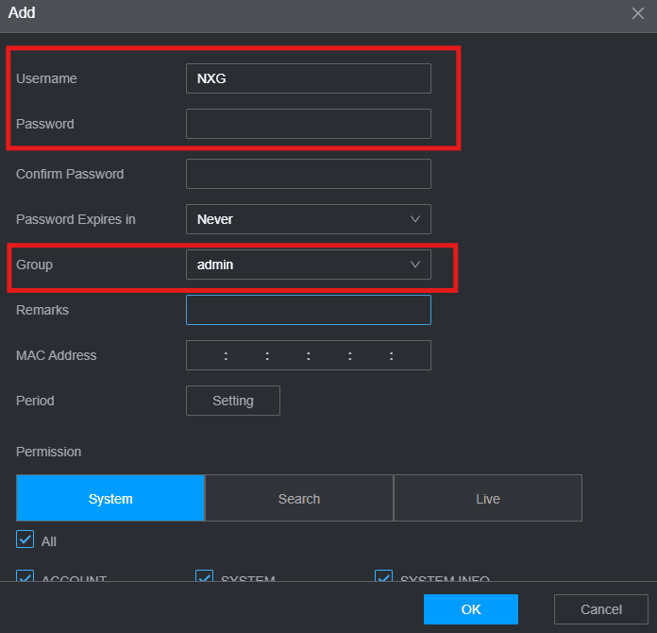
- In the new window, enter your Username and Password. We recommend using "NXG" as your Username.

- Set the permissions below:
- Manual control.
- System.
- Camera.
- System info.
- Event.
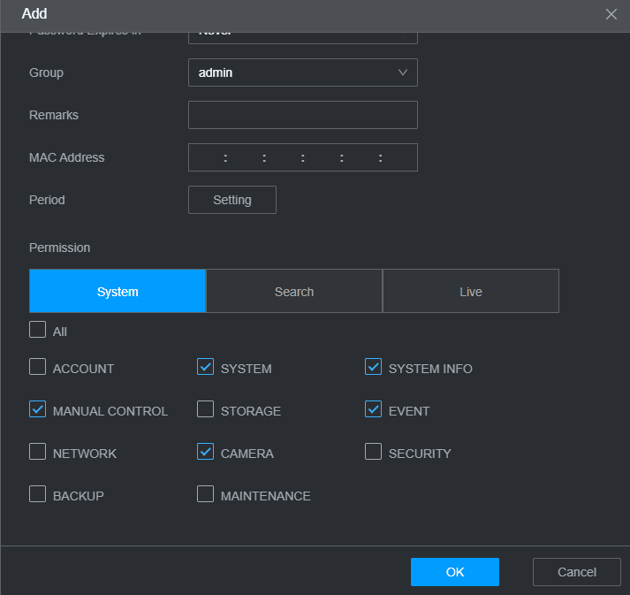
- For both Search and Live, choose the cameras you are interested to have on GCX-ONE.
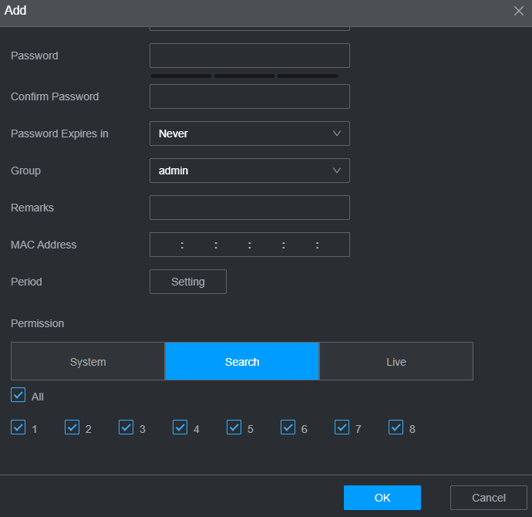

Don’t forget to press OK to save the changes.

Chapter 2: Alarm configuration (Optional).
Note: We advise against configuring motion detection, as it can trigger numerous alarms, potentially leading to an overflow of alerts on GCX-ONE.
- From the home page, go to the "Alarm" section.
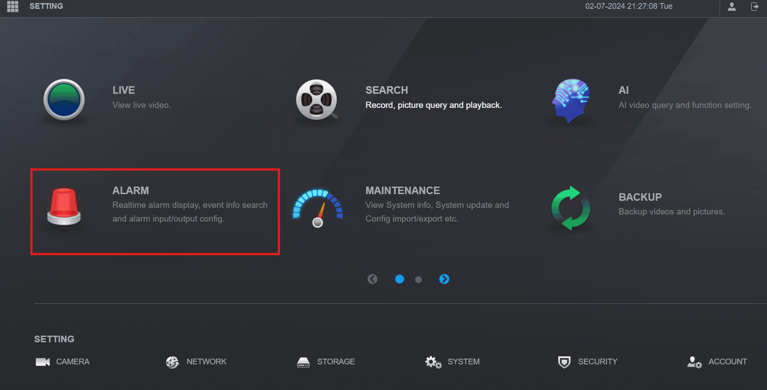
- In the Alarm menu, select "Video Detection." Here, you can configure a variety of alarms, including motion detection, video tampering, video loss, and more.
Note: The configuration steps are applicable for all types of alarms mentioned above.
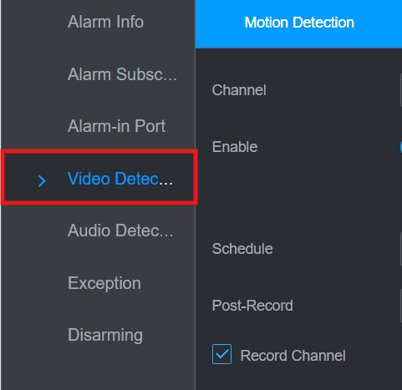
- Choose the camera you want to apply the alarm on.
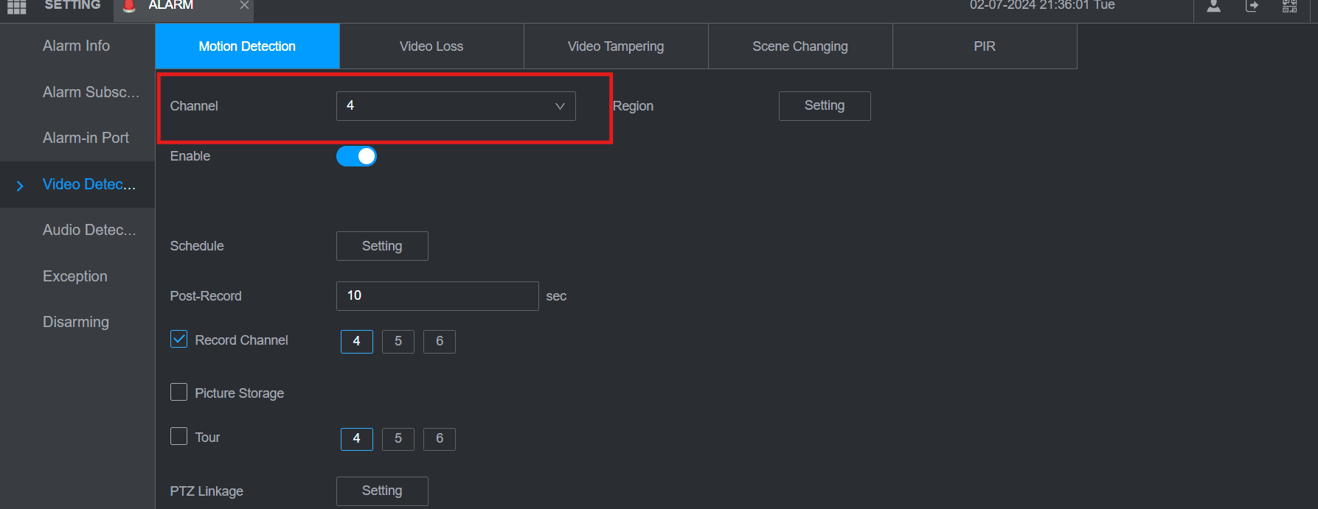
- To select the region or area of interest, click on the "Setting" button located to the right of "Channel."
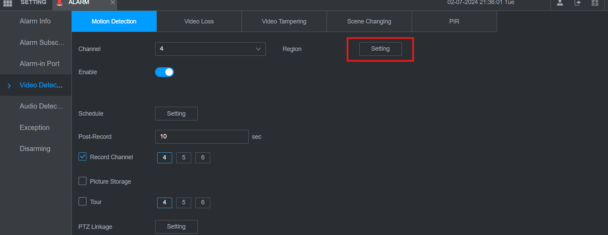
- Once the settings window appears, select the region you want to monitor. We recommend setting the sensitivity to 70 and the threshold to 5.
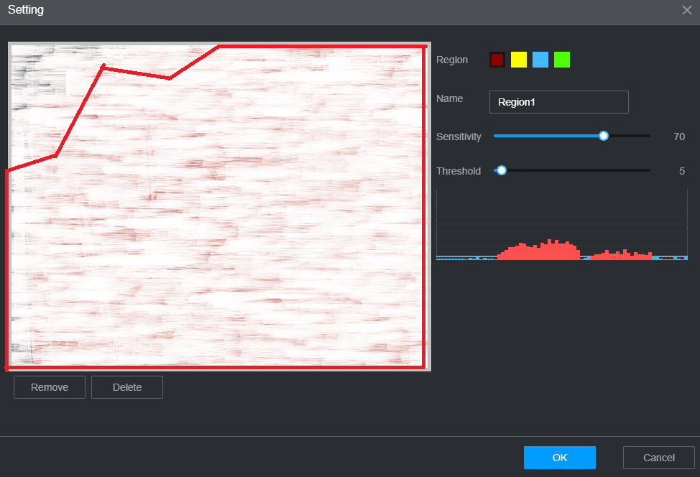
- Save the changes by clicking OK.
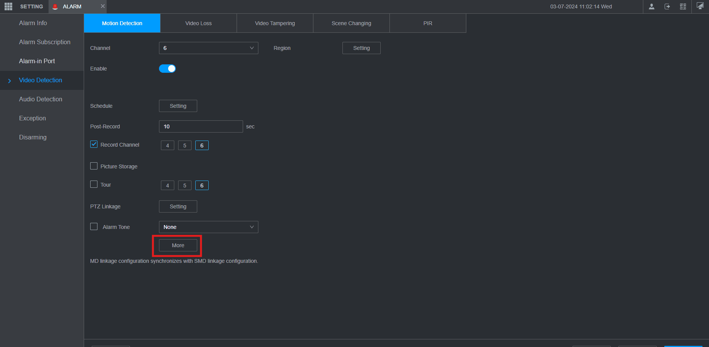
- To make the alarms available on GCX-ONE, click "More," then select "Log."
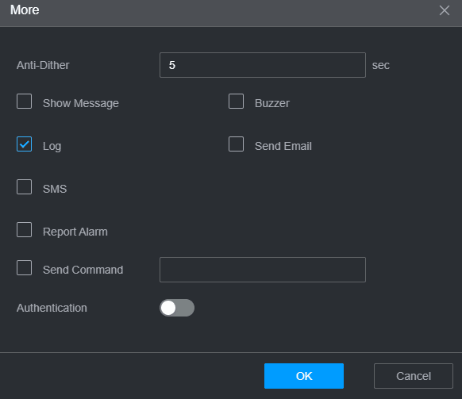
- Click on "OK" to save the changes.

Chapter 3: AI configuration (IVS).
- From the home page, go to the "AI" section.
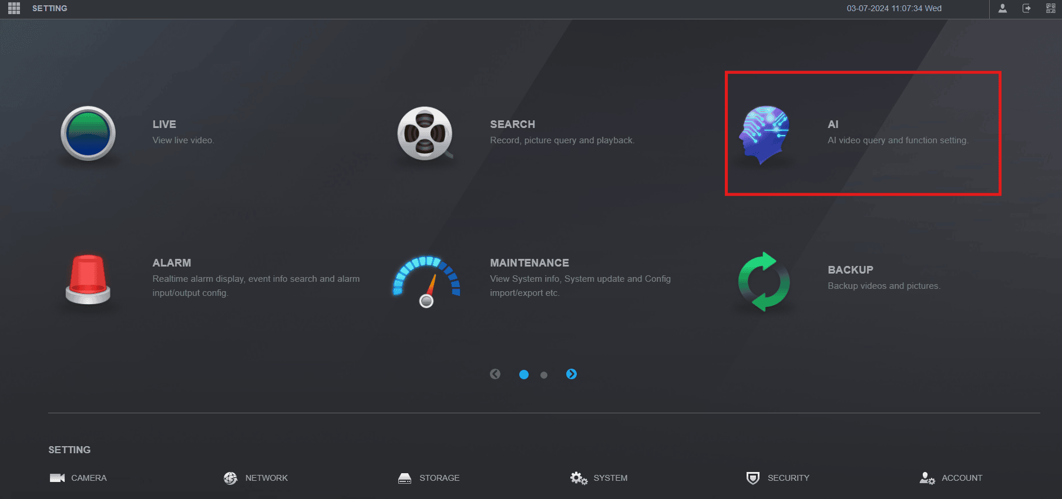
- From the menu, navigate to Parameters. then "IVS".
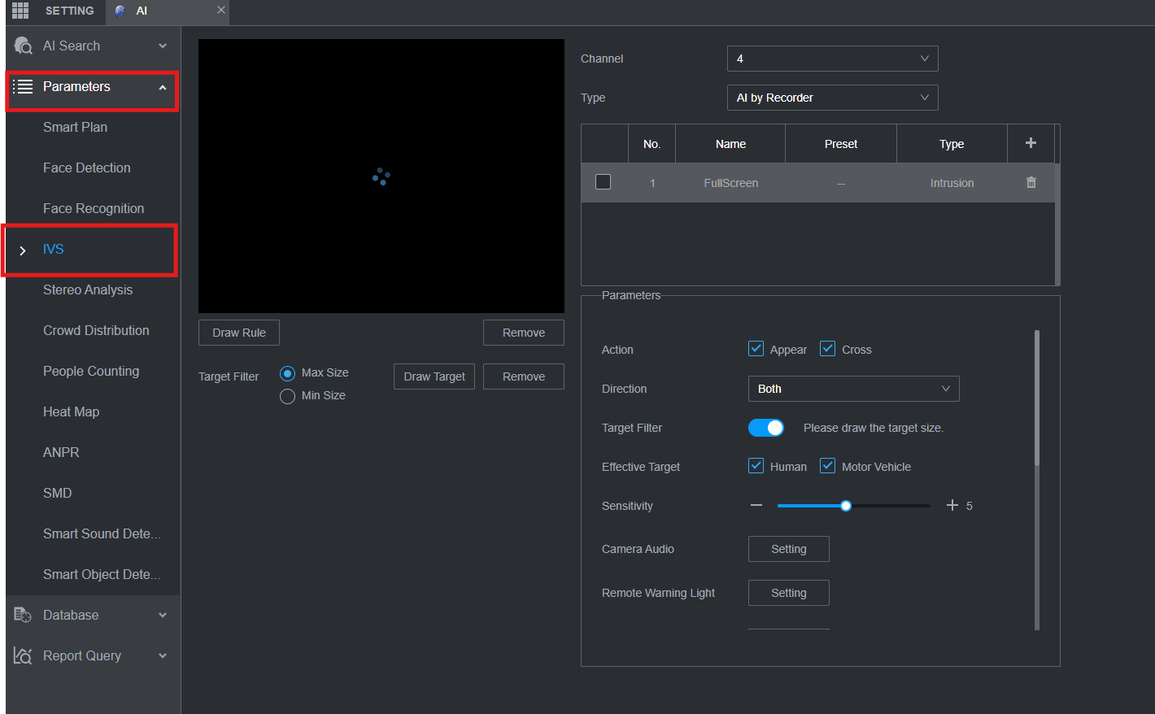
- Choose the camera you want to configure.
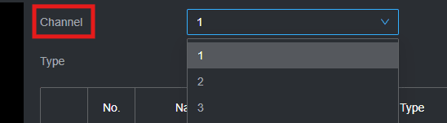
- Choose the type of configuration you want to have on the camera:
AI by Recorder: This configuration offers two types of detection:
- Tripwire Detection: This feature detects objects crossing a predefined line. You can set it to monitor different directions, such as A->B, B->A, or bidirectional.
- Intrusion Detection: Similar to Tripwire Detection, this monitors for objects crossing a boundary. However, it also requires some space outside the perimeter to detect entry effectively and exit events.
AI by Camera: This configuration Offers many options:
- Crossing Virtual Fence.
- Tripwire.
- Intrusion.
- Abandoned Object: It can be applied to the scene where the target is sparse and there is no obvious or frequent light change.
- Fast Moving: Triggers an alarm when the speed of an object exiting a defined area exceeds a specified sensitivity setting.

- Parking detection: Monitors a defined area for the presence of a vehicle that remains in the area without motion.
- Crowd Gathering Detection: Monitors a defined area for a set number of people gathering and remaining inside the defined area.
- Missing Object.
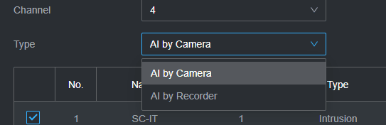
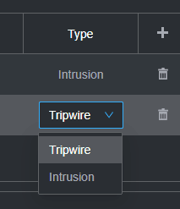
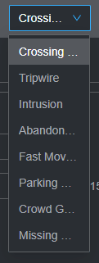
- Click the plus icon after choosing"AI by Camera" for example.
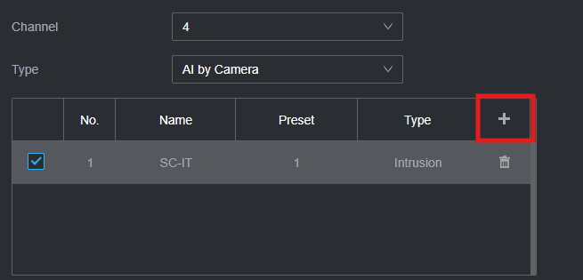
- Choose the type of detection you want to have:
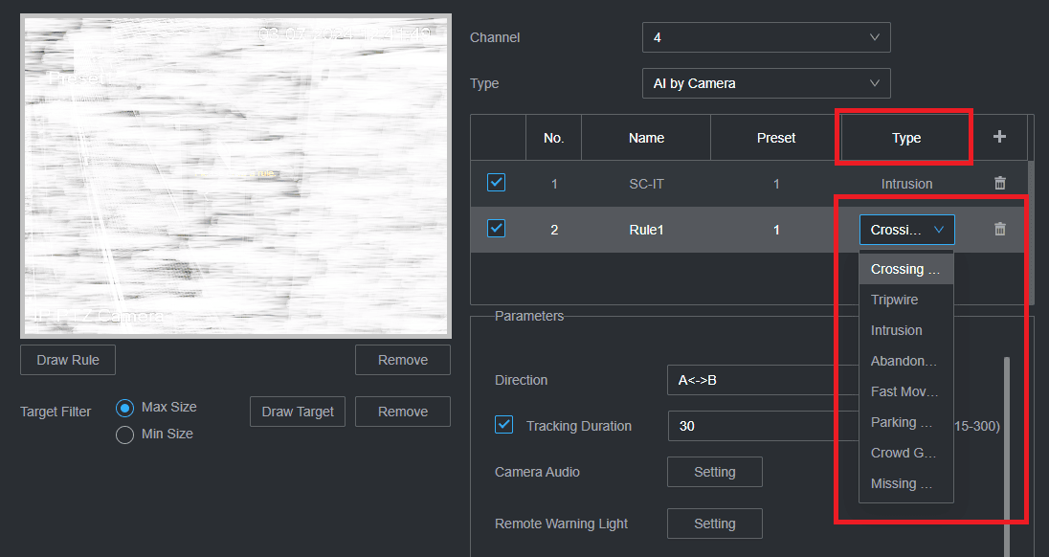
- If you select "Intrusion" as an example, you will select the following parameters:
- Action: Appear or Cross.
- Target filter: draw the area of interest on the image by clicking"Draw Rule" under the picture.
- Tracking duration: We recommend setting it to 30 seconds.
- Schedule: Specify the duration for which you want to receive alarms from the camera.
- Effective Target: Human and Motor Vehicle.

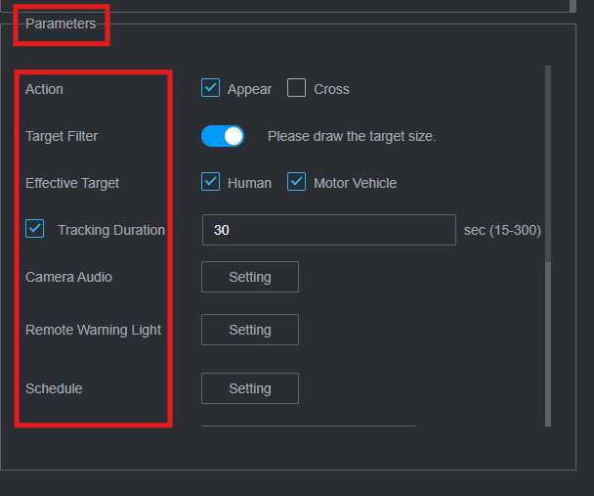
- Scroll down on the parameters section, then click on "More":

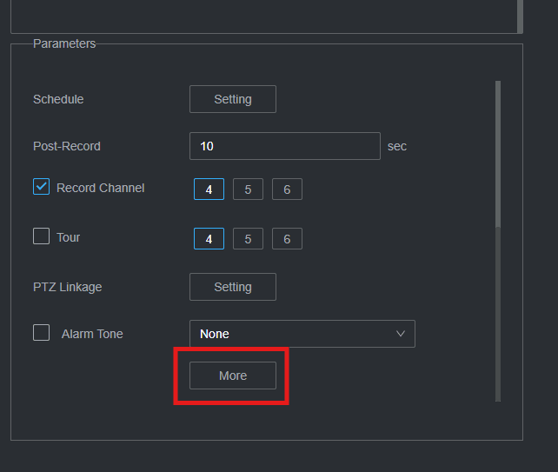

- When the new window appears, click on "Log" and then "Report Alarm." This action will enable the device to push alarms to the GCX-ONE platform.
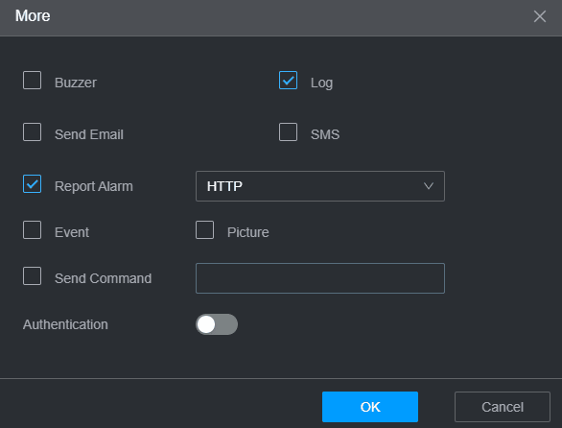
Note: The configuration steps are applicable for all types of alarms mentioned above.
These steps and explanations will help you configure the appropriate analytics on your Dahua device to enhance your security system’s effectiveness and responsiveness.

Dahua Device configuration Guide with GCX-ONE
Step 1: Log in to GCX-ONE.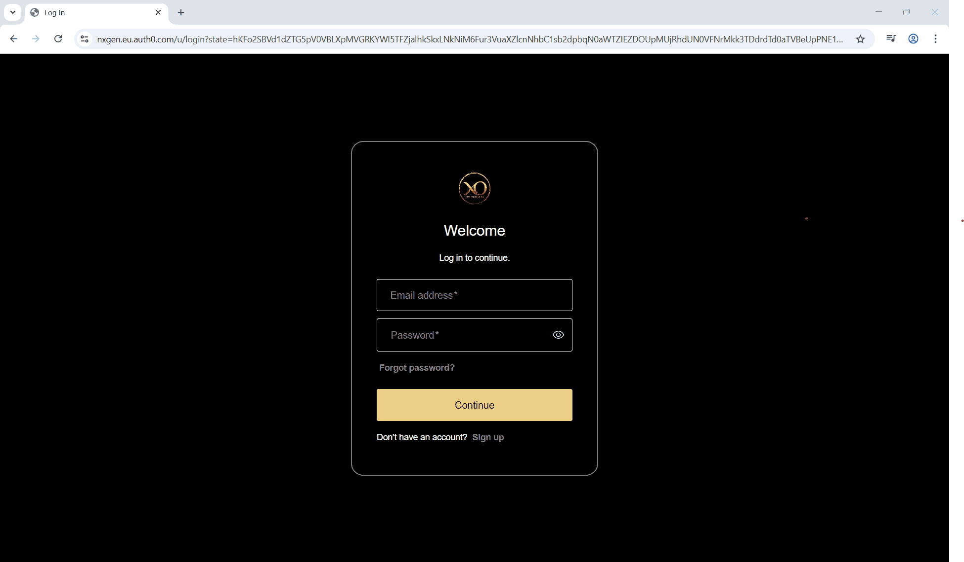
Step 2: Click on the Configuration menu.
Step 3: At the Service Provider level, click on Customers.
Step 4: Click the Add button.
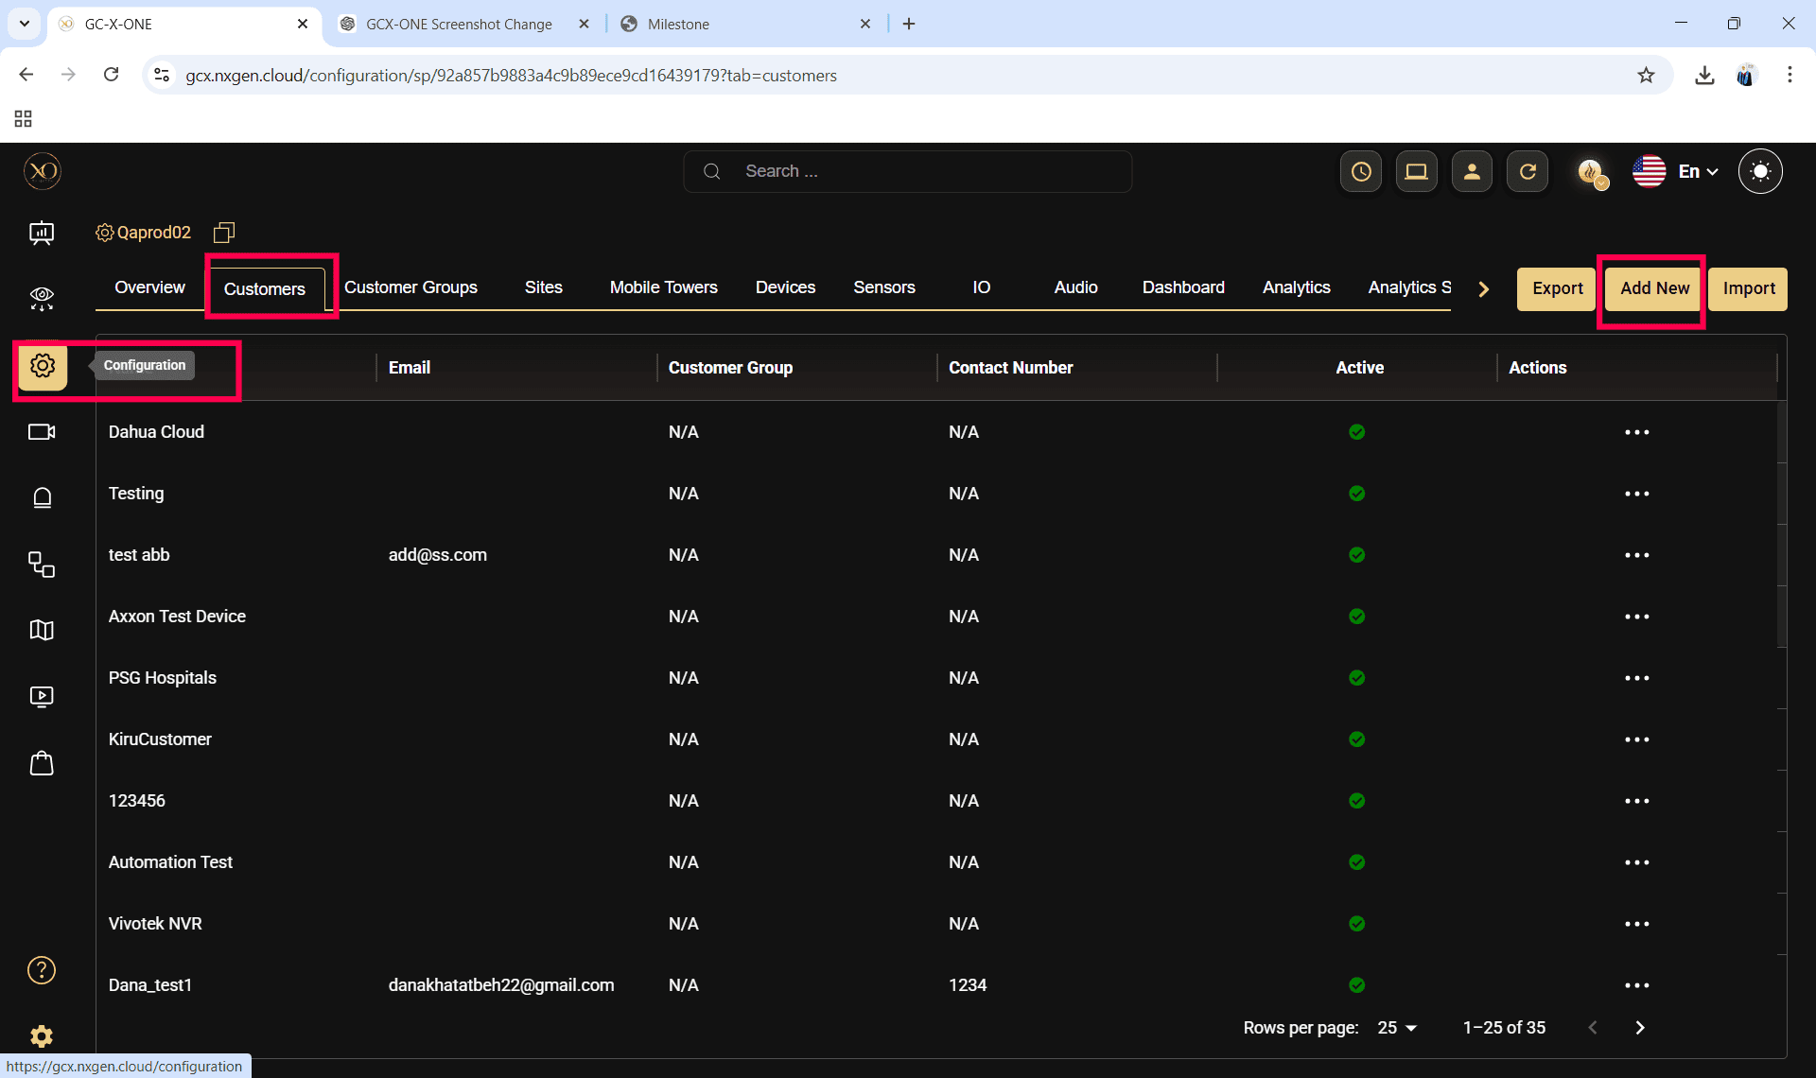

Step 5: Enter the required fields and click Save.
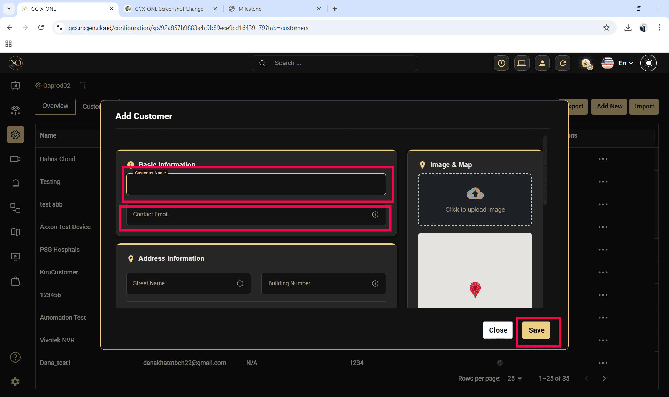
Step 6: Select the newly created customer.
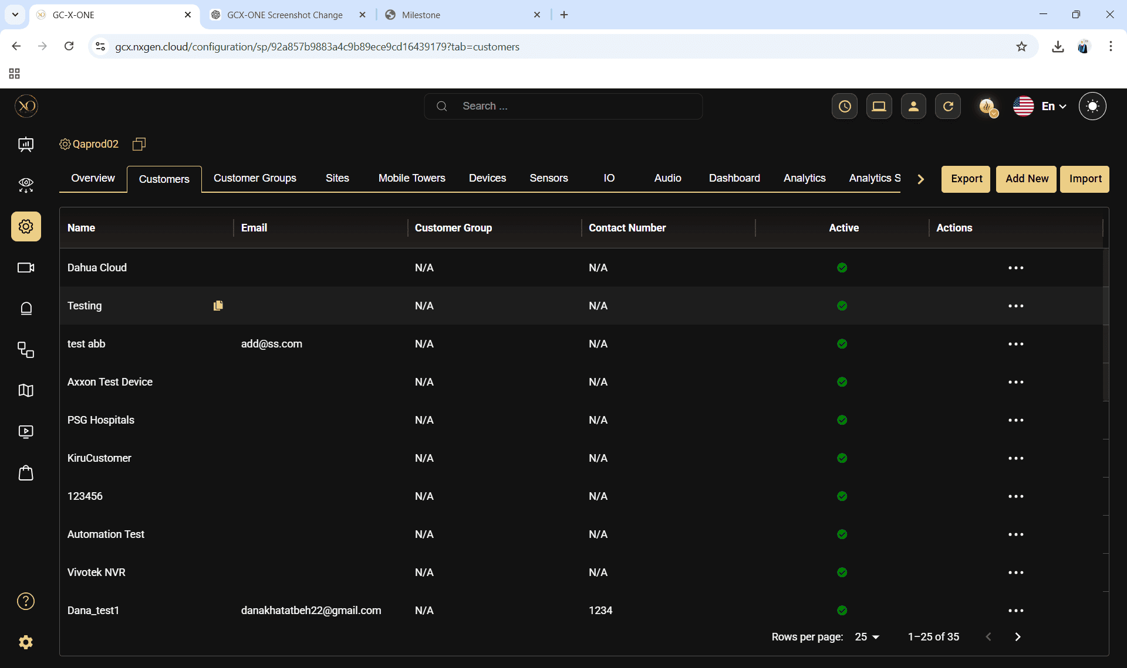

Step 7: Navigate to the Sites tab.
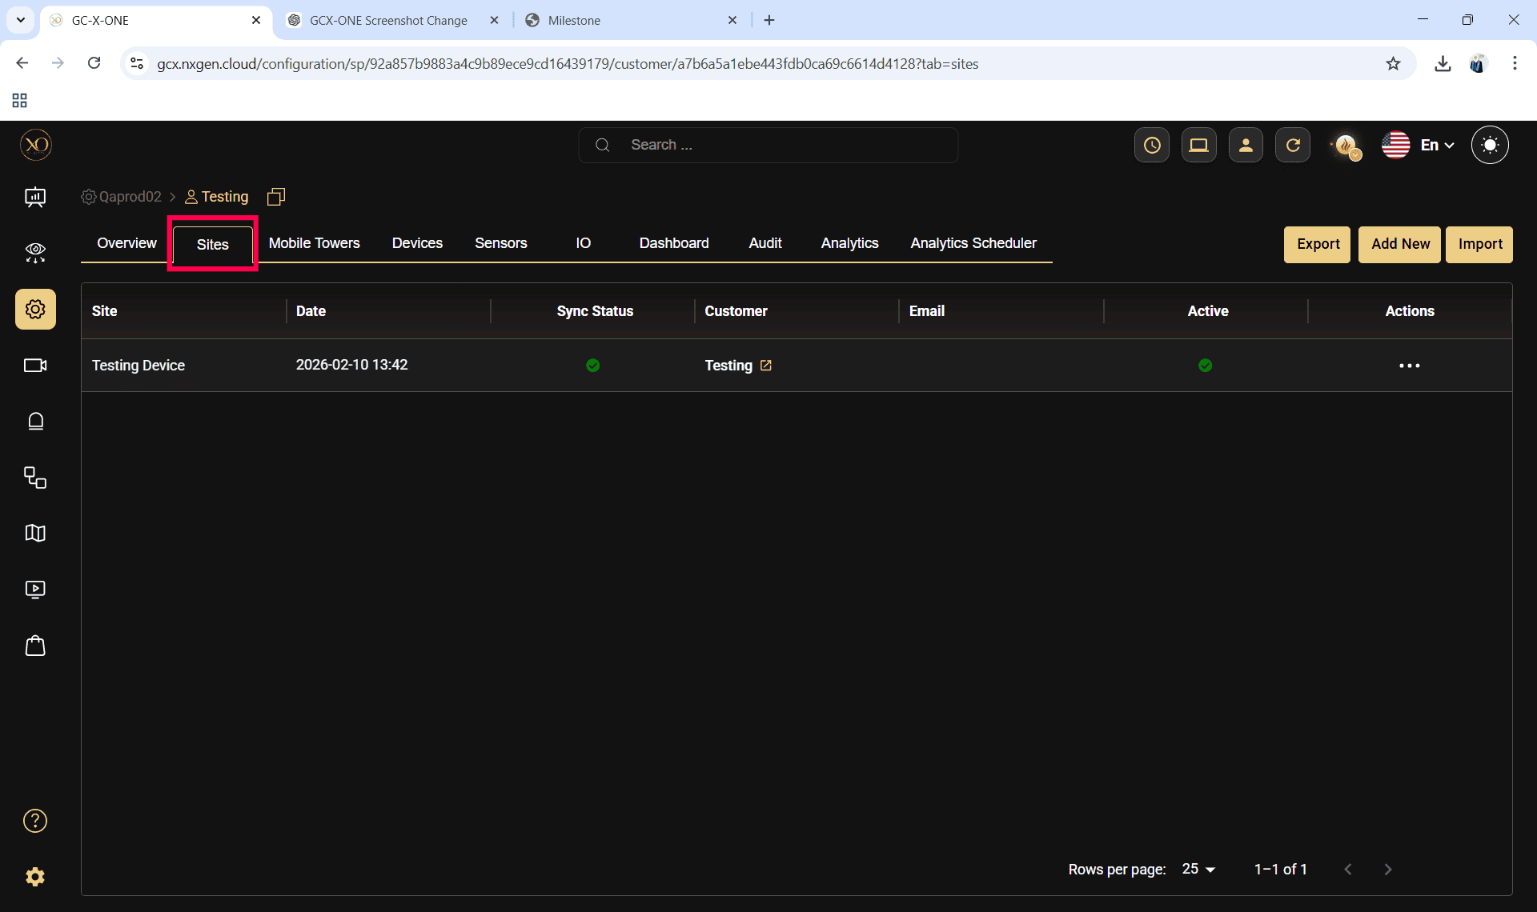
Step 8: Click the Add button.
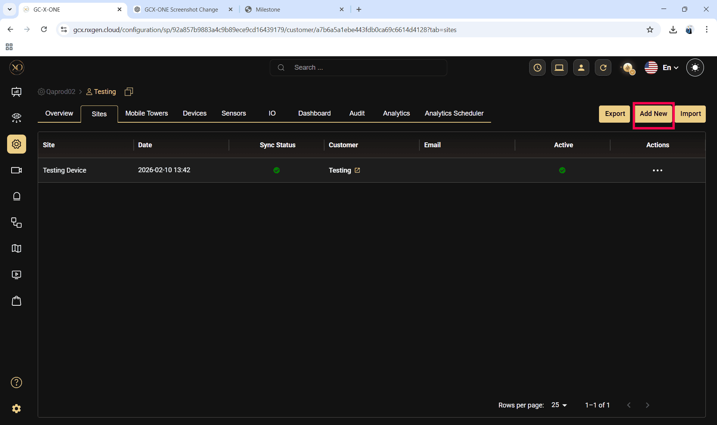

Step 9: Enter the required fields and click Save.
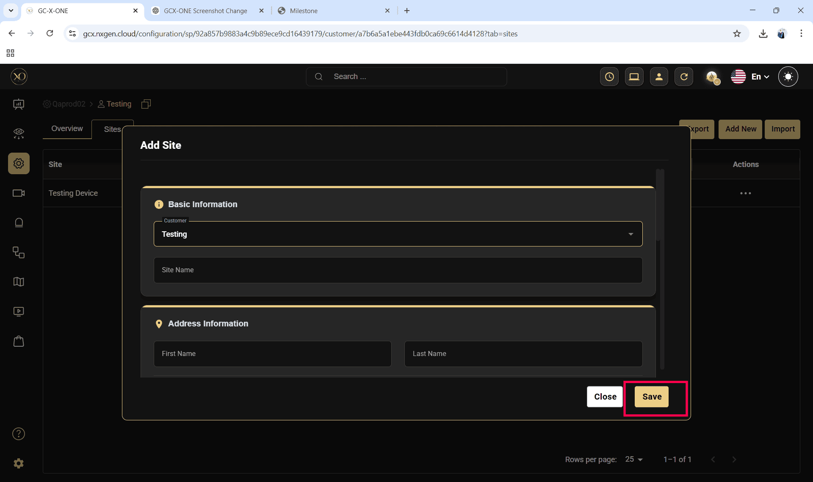

Step 10: Select the newly created site.
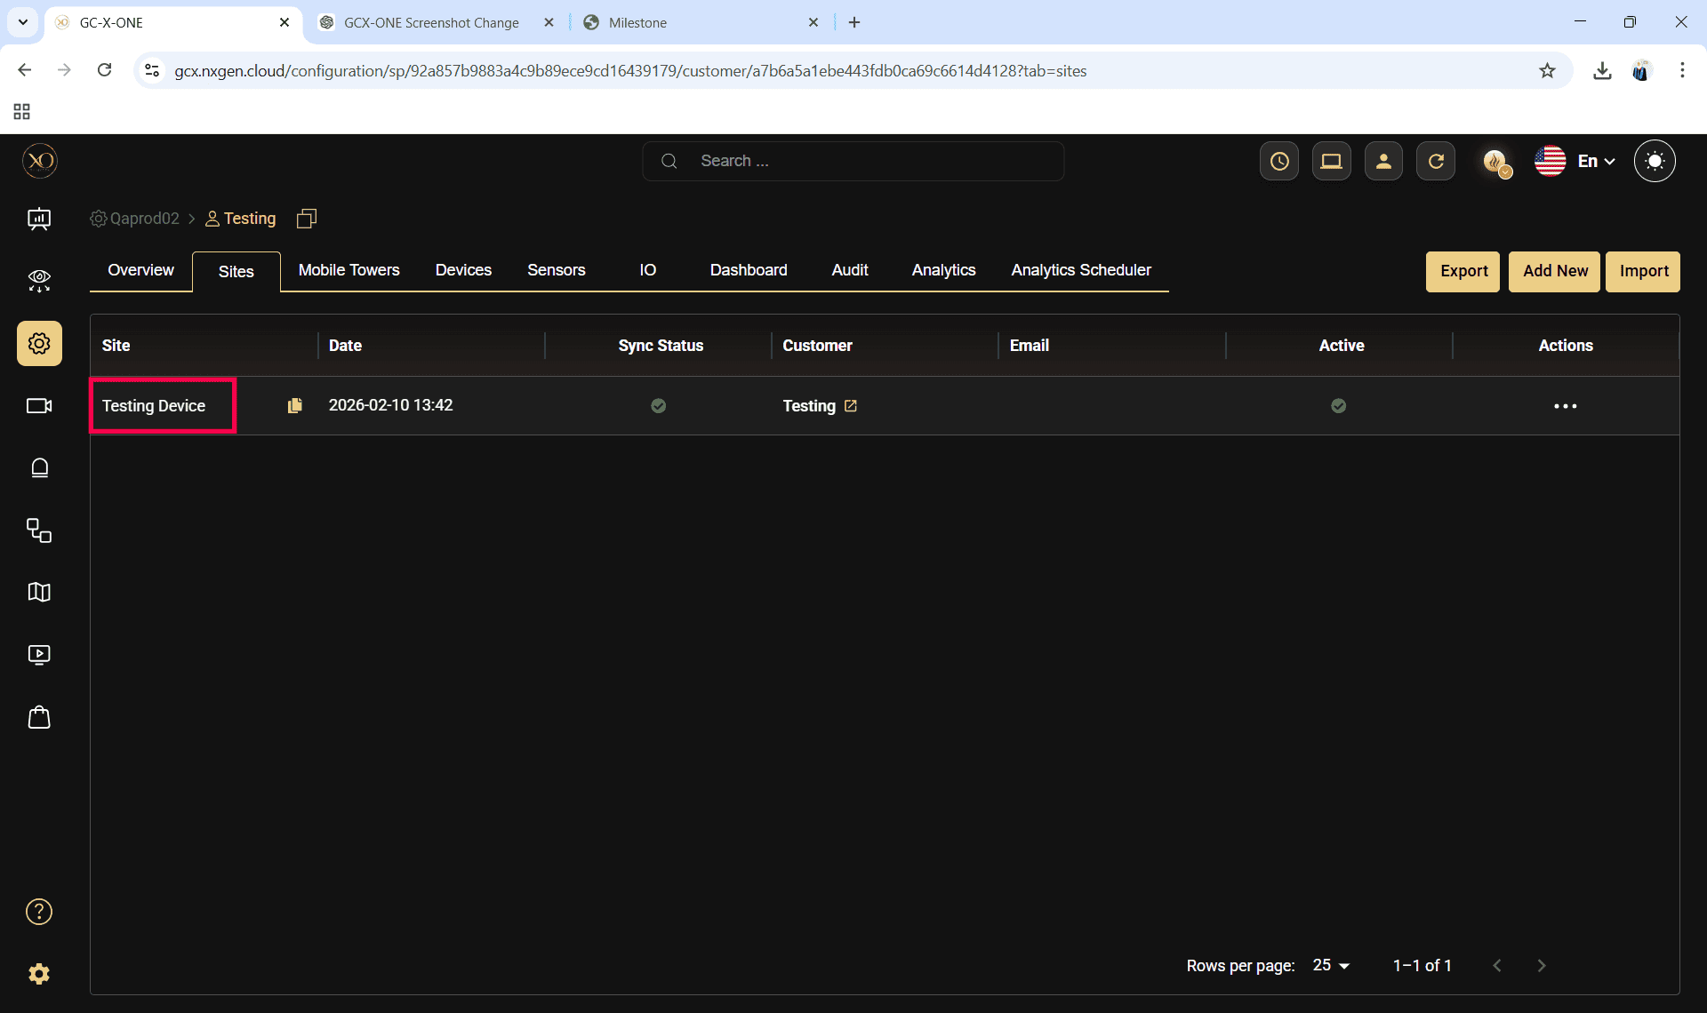

Step 11: Navigate to the Devices tab.
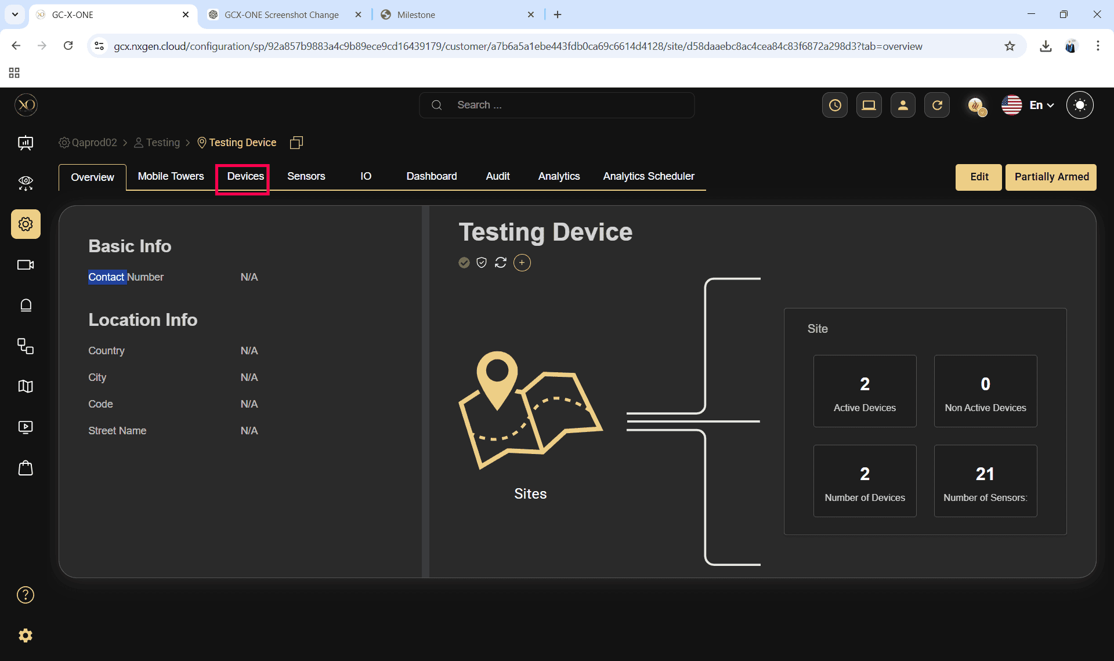
Step 12: Click the Add button.
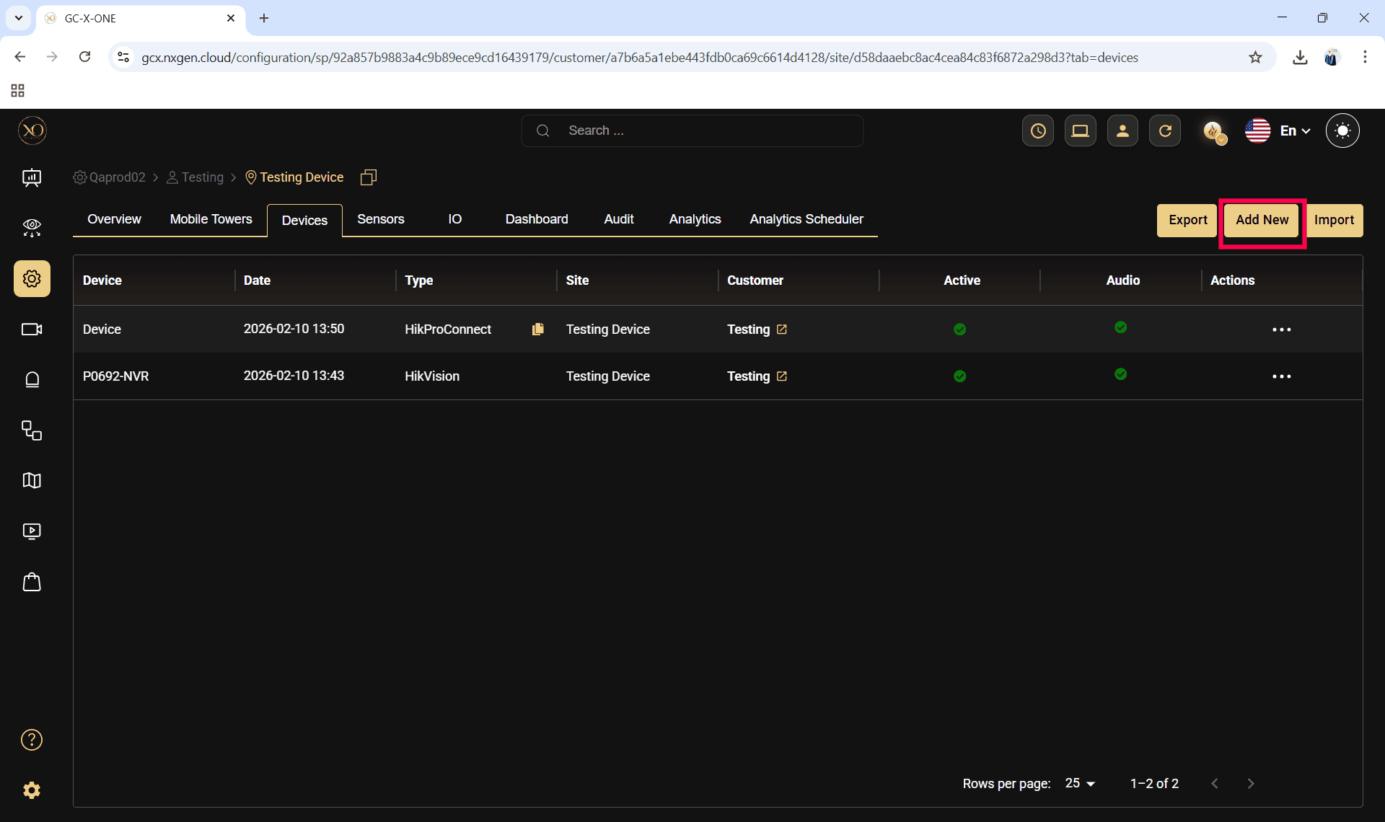

Step 13: The Add Device dialog will be displayed.
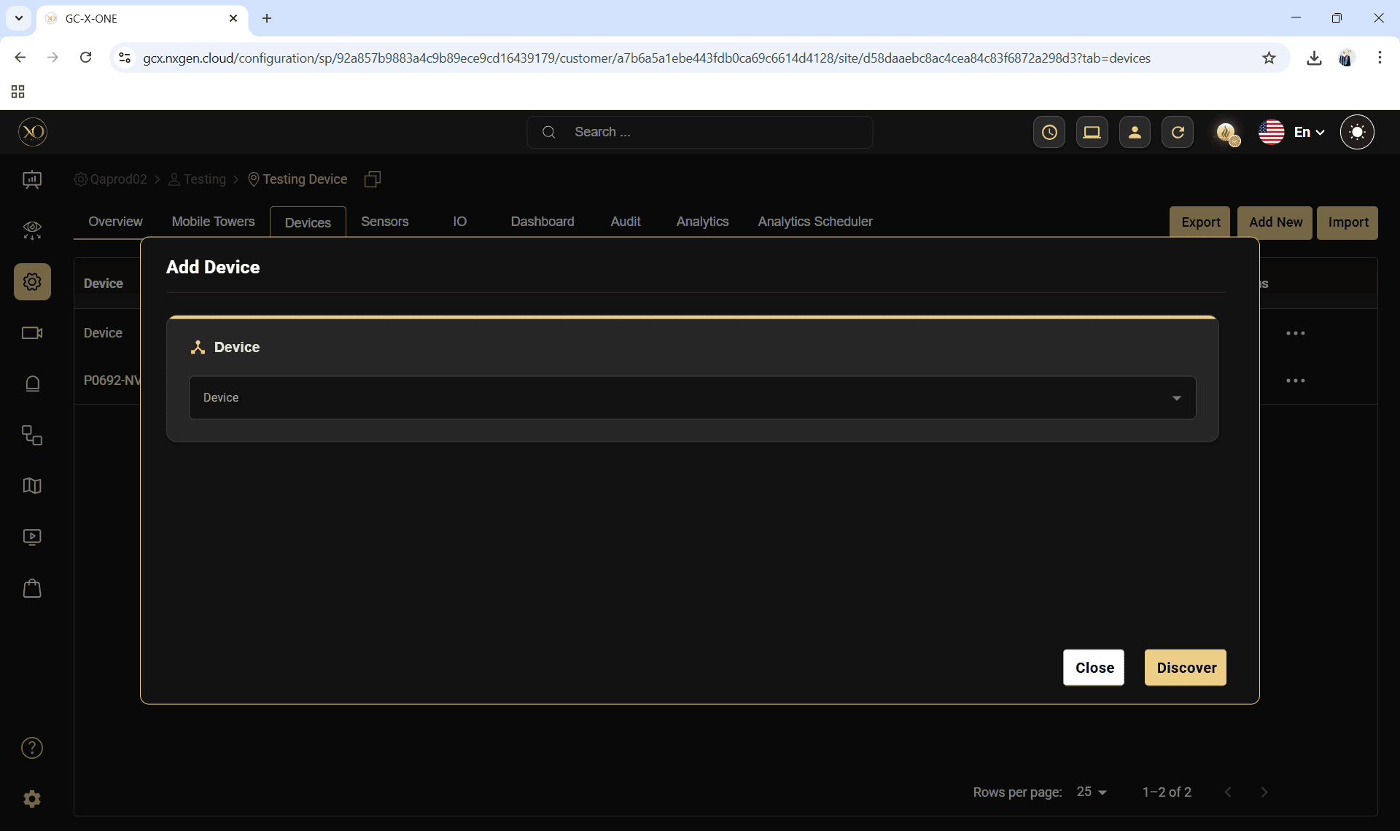

Step 14: In the dialog, open the Device dropdown and select Dahua.

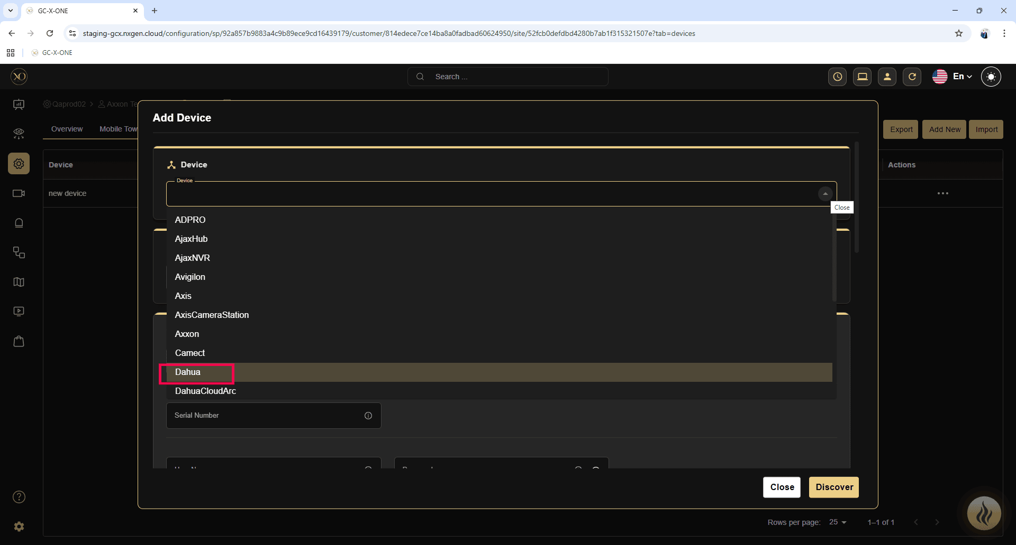

Step 15: Enter all required fields:
- Name
- IP Address or Host
- Username
- Password
- HTTPS Port
- TCP Port
- RTSP Port
- HTTP Port
- Time Zone

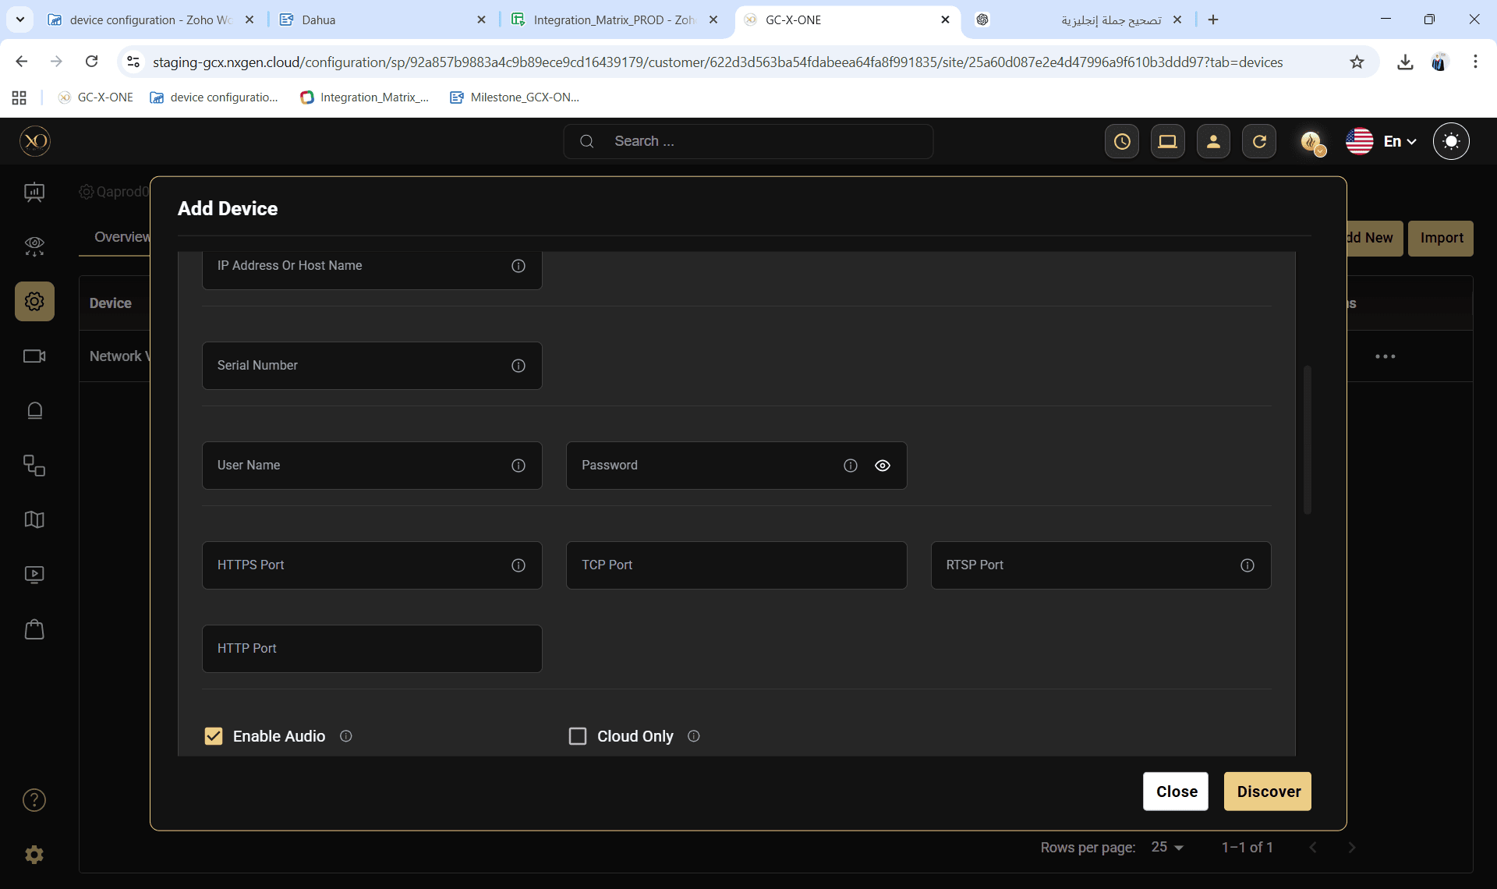

Step 16: Click Discover.
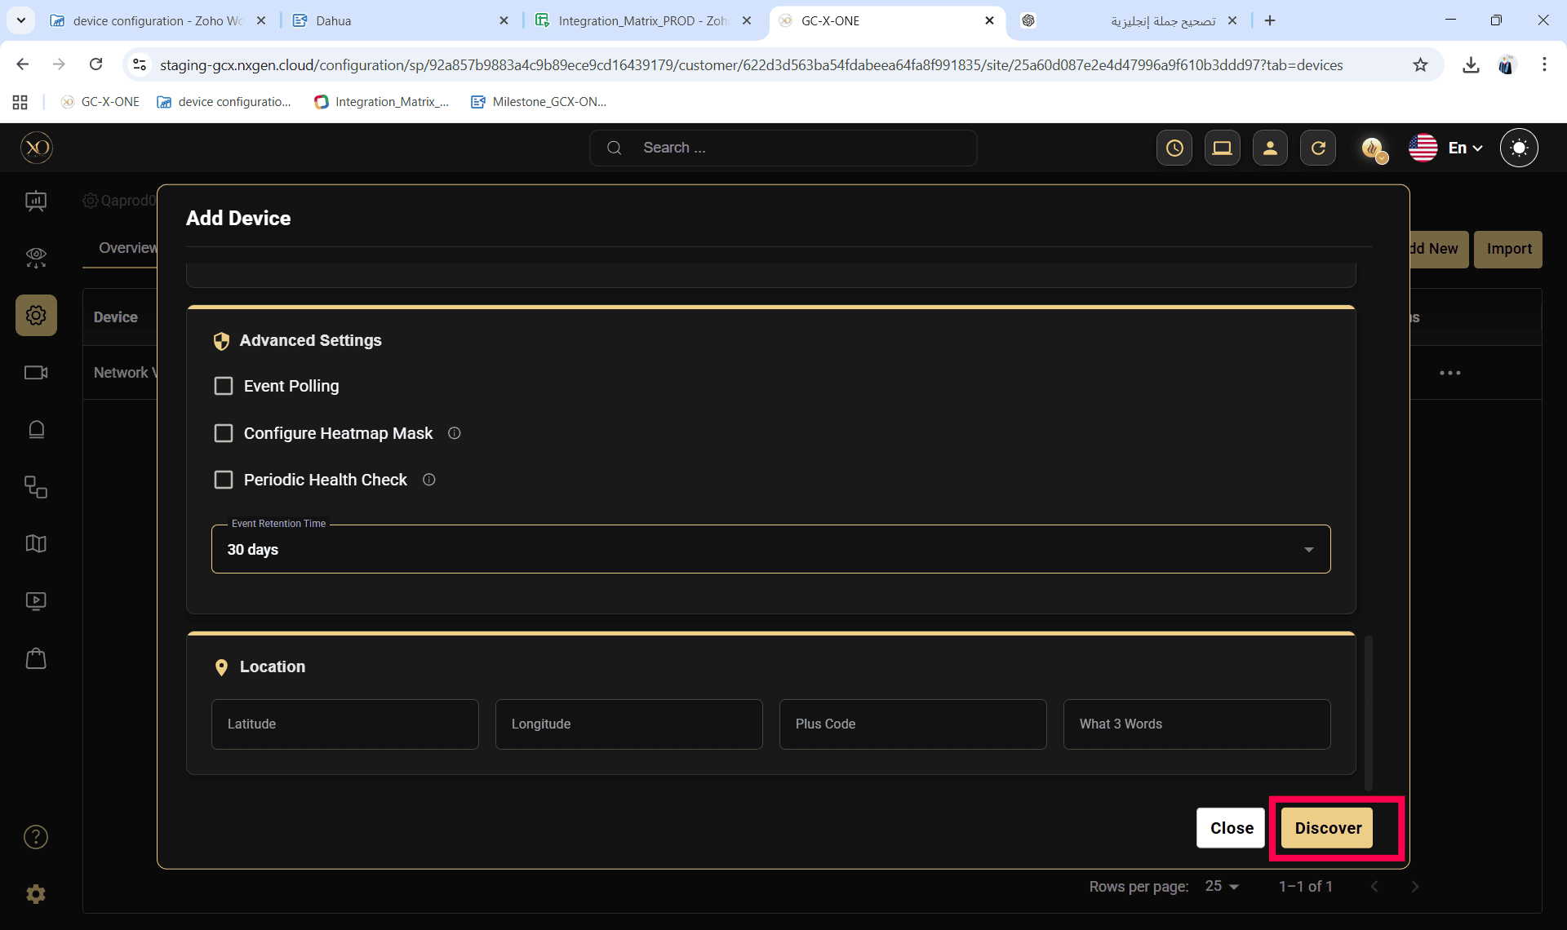

Step 17: Once the device is successfully discovered, click Save.
